**Clouds: The Next-Gen Fundamental Building Blocks – PaaS**

**RFG POV:** There is no doubt that cloud platform as a service (PaaS) is garnering general appeal to all IT segments and will become a primary building block for applications development and operations in the future. However, PaaS offerings are very immature and come in a variety of flavors that lack full compatibility, completeness, and interoperability. IT executives need to understand PaaS models, definitions, interoperability characteristics, and alternatives before selecting the platforms that will become the basis for future development and operations.

PaaS is a very muddled category as it includes every Cloud middleware, orchestration, automation or enablement solution that cannot logically or easily be called a SaaS (Software as a Service) solution, such as Salesforce.com, or an IaaS provider. Indeed, virtually every IaaS provider has developed its own PaaS layer or is partnering, reselling or is an OEM for an existing PaaS solution. AWS offers its [*Elastic Beanstalk*](http://aws.amazon.com/elasticbeanstalk/), and IBM has invested heavily in *BlueMix*, while HP partners with a variety of suppliers, including open source–based [Cloudify](http://getcloudify.org/) and [ActiveState](https://community.hpcloud.com/article/how-do-i-set-activestate-stackato-hp-helion-public-cloud), and Cisco with SunGard AS.

A January 2014 [Gartner iPaaS MQ](http://www.gartner.com/it-glossary/information-platform-as-a-service-ipaas/) specifically focused on enterprise integration PaaS providers includes 17 solution providers with Dell, IBM, Informatica and MuleSoft among the top rated. In a previous research note entitled, [*Platform as a Service: Definition, Taxonomy and Vendor Landscape, 2013*](https://www.gartner.com/doc/2515316/platform-service-definition-taxonomy-vendor), Gartner identified no less than 15 classes of PaaS, “each roughly mirroring a corresponding class of on-premises middleware products.” By definition, this list would not include PaaS developed exclusively for use by public CSPs such as AWS, Microsoft and others.

**Gartner predicts, “Dramatic growth in the iPaaS market over the next five years due to several factors, including:**

* The explosion of CSI [Cloud services integration], MAI [mobile app integration], API and Internet of Things requirements;
* The emergence of the agile integration approach and citizen integrators, for which traditional integration platforms are unsuitable and;
* Adoption by SMBs so far often unwilling to embrace integration middleware because of its high cost and complexity, but now interested in iPaaS offerings due to their low entry cost and ease of use.”

**The breadth of PaaS offerings is staggering, creating more confusion and uncertainty for enterprises trying to develop their own private Cloud solutions or those enterprises evaluating CSPs to align with for bursting, backup, disaster recovery or Tier 1 application hosting services – all in the name of business agility, application enablement and lower cost.**

**PaaS – Platform as a Service Providers**

As with the other categories, the following vendors are a representative example of PaaS solution providers, not an exhaustive list.

[ActiveState](http://www.activestate.com/) is the parent company for Stackato, based on Cloud Foundry, which “makes it easy to develop, deploy, migrate, scale, manage, and monitor applications on any Cloud,” available in Enterprise, Micro Cloud, and Sandbox editions. HP Helion began an OEM relationship with ActiveState in late 2012 including [*Stackato*](https://marketplace.hpcloud.com/stackato) as part of its PaaS portfolio for “building applications for creating private PaaS using any language on any stack on any Cloud. Additionally, enterprise IT can achieve new levels of data security, reduce time to market, save money, ensure compliance, and gain greater control over the Cloud.” Ease of use and agility is achieved through narrowing the gap between development, test and production.

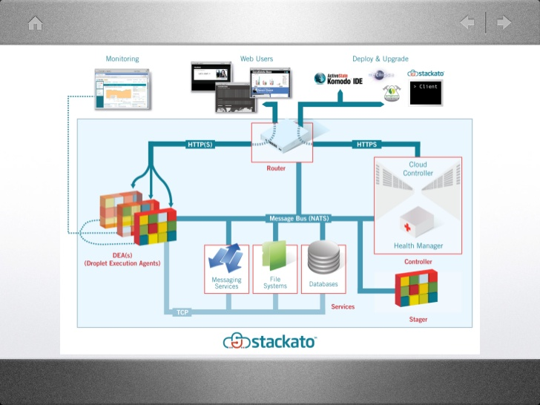

[Citrix](http://www.citrix.com/products/cloudplatform/overview.html) CloudPlatform offers “simple, turn-key Cloud orchestration. CloudPlatform is the only Cloud orchestration platform that enables you to quickly and efficiently build a future-proofed Cloud. It is a turn-key solution based on an open and flexible architecture that is designed to run every application workload at scale and with simplicity.” In July 2011, Citrix acquired CloudStack developer [Cloud.com](http://en.wikipedia.org/wiki/Cloud.com), now available through an Apache Software open source license. Considered one of the early Cloud orchestration innovators, Citrix has morphed Cloud.com into CloudPlatform and claims more than 2,500 Cloud providers as users, including AWS. CloudPlatform also leverages standard AWS APIs and a rich partner ecosystem as well as offering its own [Turnkey IaaS](http://www.citrix.com/solutions/turnkey-iaas-cloud-platform/overview.html).



[Docker](https://www.docker.com/whatisdocker/) is an “open platform for developers and sysadmins to build, ship and run distributed applications. Consisting of Docker Engine, a portable, lightweight runtime and packaging tool, and Docker Hub, a Cloud service for sharing applications and automating workflows, Docker enables apps to be quickly assembled from components and eliminates the friction between development, QA, and production environments. As a result, IT can ship faster and run the same app, unchanged, on laptops, data center VMs, and any Cloud.” Whether on-premise bare metal or data center VMs or public Clouds, workload deployment is less constrained by infrastructure technology and is instead driven by business priorities and policies. The Docker Engine container comprises just the application and its dependencies.

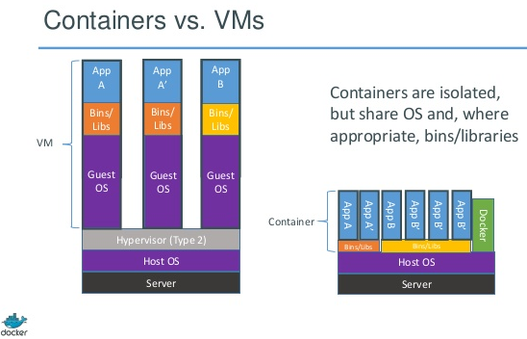

[GigaSpaces](https://mail2.rfgonline.com/owa/redir.aspx?C=4CzDiGb-FkSvMpoigxpW84hw-_XPidEIuMYDM9M1zwETOqjjKZrY7xzmGgy8tVK0SVOCDYarzfs.&URL=http%3a%2f%2fwww.gigaspaces.com%2f" \t "_blank) Technologies provides software middleware for deployment, management and scaling of mission-critical applications on Cloud environments through two main product lines, [XAP In-Memory Computing](https://mail2.rfgonline.com/owa/redir.aspx?C=4CzDiGb-FkSvMpoigxpW84hw-_XPidEIuMYDM9M1zwETOqjjKZrY7xzmGgy8tVK0SVOCDYarzfs.&URL=http%3a%2f%2fwww.gigaspaces.com%2fxap-in-memory-computing-event-processing%2fMeet-XAP" \t "_blank) and [Cloudify](https://mail2.rfgonline.com/owa/redir.aspx?C=4CzDiGb-FkSvMpoigxpW84hw-_XPidEIuMYDM9M1zwETOqjjKZrY7xzmGgy8tVK0SVOCDYarzfs.&URL=http%3a%2f%2fwww.gigaspaces.com%2fcloudify-devops-cloud-application-management%2fmeet-cloudify" \t "_blank). “Hundreds of Tier-1 organizations worldwide are leveraging GigaSpaces’ technology to enhance IT efficiency and performance, from top financial firms, e-commerce companies, online gaming providers, healthcare organizations and telecom carriers.” GigaSpaces recently released its 3.0 version of Cloudify with an open source community version along with a much-improved premium edition that includes an enhanced UI, plug-ins for standard tools, advanced blueprints, elastic caching and Replication as a Service, making it “even easier for enterprises to automate and manage apps and take Cloud orchestration to the next level.”

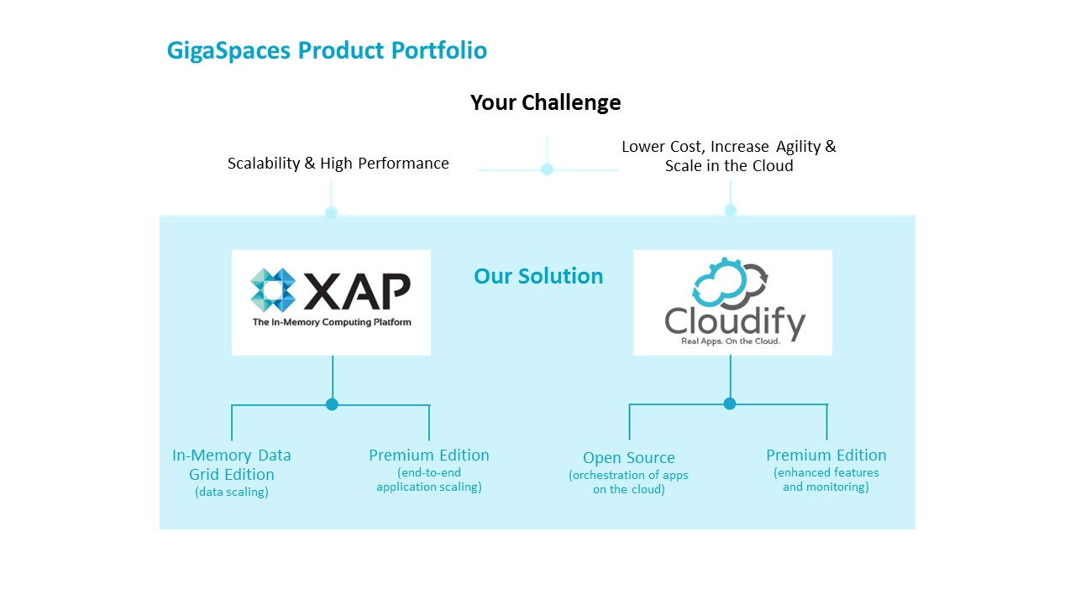

[Informatica](http://www.informaticacloud.com/platform) Cloud’s integration platform-as-a-service (iPaaS) allows enterprises to “extend the capabilities of Informatica Cloud through a variety of development tools, including a REST API and a Java-powered Cloud Connector SDK. Its multi-tenant iPaaS offers benefits for enterprises, including breaking down the walls of data, process and service integration by having a common set of artifacts; increasing collaboration between integration and application developers, as well as ETL and EAI architects; and rapidly connecting to homegrown, proprietary, or legacy systems through [REST](https://community.informatica.com/solutions/rest_web_services_connector" \t "_blank) or [SOAP](https://community.informatica.com/solutions/infacloud_webservice_connector" \t "_blank) web services, as well as emerging data standards such as [JSON](https://community.informatica.com/solutions/cloud_json_connector" \t "_blank) or [OData](https://community.informatica.com/solutions/odata_connector" \t "_blank).” Informatica iPaaS also offers independent software vendors and system integrators to quickly onboard customer apps and cut the time and cost of integration projects.

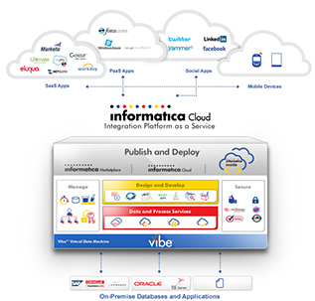

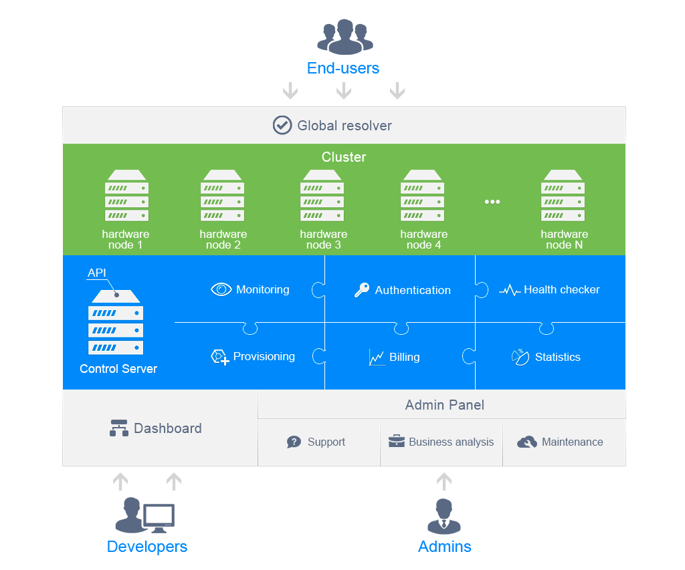[Jelastic](http://jelastic.com/solutions/jelastic-for-enterprise/) offers “Platform-as-Infrastructure, the integration of Infrastructure-as-a-Service and Platform-as-a-Service, delivering a scalable, manageable and highly available Cloud.” DevOps can deliver a “private or hybrid enterprise Cloud that drives down costs and increases agility. Provide your developers with an enterprise-class private PaaS that enables rapid application development and deployment without coding to proprietary APIs.” Jelastic automates horizontal and vertical scaling and provides denser packing of applications hosted by CSPs, while also facilitating dynamic sizing and live migration of containers such as Docker. Jelastic “simplifies” Private Cloud by providing an infrastructure that is “easy to deploy and simple to manage the entire enterprise stack and can install on ‘bare metal’ servers.”

[Mirantis](https://mail2.rfgonline.com/owa/redir.aspx?C=LU9w9WywT0GH9p0JcQmChfooeNDBENEIjxoQxb6CjdxKU9Vf6cJ2ZR1hbIKmyn5qCz0hu0Rew_A.&URL=http%3a%2f%2fwww.mirantis.com" \t "_blank) is the “number one pure-play OpenStack solutions provider, the most progressive, flexible, open distribution of OpenStack, combining the latest innovations from the open source community with the testing and reliability customers expect. More customers rely on Mirantis than any other company for the software, services, training and support needed for running OpenStack Cloud.” Mirantis is the only pure-play OpenStack contributor in the top five companies contributing open source software to OpenStack and supports many Global 1,000 companies such as AT&T, Cisco WebEx, Comcast, Dell, The Gap, NASA, NTT Docomo and PayPal to build and deploy production-grade OpenStack. Mirantis OpenStack is a “zero lock-in distro that makes deploying Cloud easier, more flexible and more reliable,” while OpenStack Express is an “on-demand Private-Cloud-as-a-Service” that allows users to deploy workloads “immediately.”

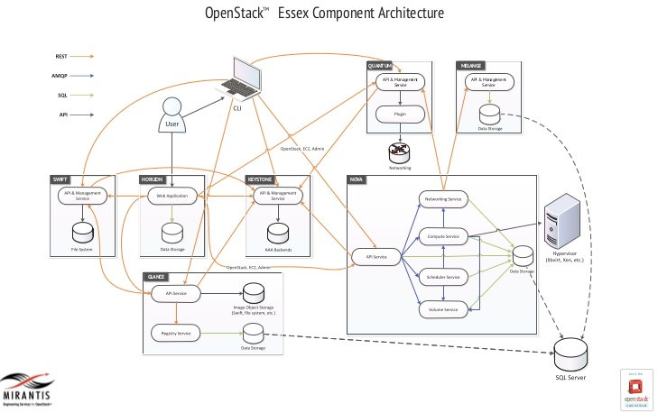

[MuleSoft](http://www.mulesoft.com/) provides the most widely used integration platform for connecting any application, data source or API, whether in the Cloud or on-premises. With Anypoint™ Platform, MuleSoft delivers a complete integration experience built on proven open source technology, eliminating the pain and cost of point-to-point integration. Anypoint Platform includes CloudHub™ iPaaS, Mule ESB™ and a unified solution for API management, design and publishing. “CloudHub is the fastest way to integrate SaaS applications reliably and securely. The platform of choice for enterprise integration, CloudHub offers global availability and 99.99% uptime. Compliance with the highest security standards ensures integrations are protected wherever they run.” MuleSoft has more than 170 enterprise customers.

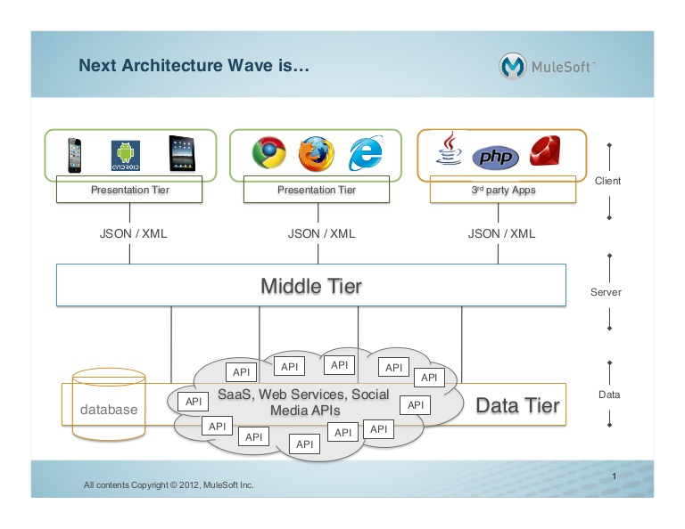

**Managed Cloud Services Providers**

Many of the above-mentioned IaaS solution providers also offer Managed Cloud Services, including IBM and SunGard Availability Services. Telcos such as AT&T, NTT and Verizon also have viable offerings in this space. This space is also crowded with hundreds of service providers of every ilk. The primary reason for this is MCSPs make the transition to the Cloud much easier for most organizations.

The two examples below are MCSPs that leverage other provider networks/datacenters and specialize – although not exclusively – within specific application areas (e.g. Avanade for Microsoft applications) or within specific industries (e.g. DataPipe in financial services).

[Avanade](http://www.avanade.com/en-us/offerings/pages/private-cloud-managed-services.aspx) “Private Cloud solution is built on the latest Microsoft technologies, including Windows Server 2012, System Center 2012 and Avanade’s own Cloud Services Manager software. These technologies enable IT to improve productivity, optimize operations, lower costs, tighten security and reduce your environmental footprint. Avanade also offers scalable, infrastructure-managed services that can help you rapidly cut costs. We offer a comprehensive selection of managed services including Service Desk coverage, Workplace Services, Data Center Services, Network Services and Security Services.” A joint venture between Accenture and Microsoft, Avanade seeks to accelerate the business value of Private Cloud with tailored managed services while providing clients with a flexible, agile business approach.



**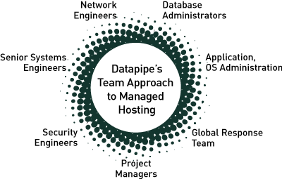**[Datapipe](http://www.datapipe.com/) offers a single provider solution for managing and securing mission-critical IT services, including Cloud computing, infrastructure as a service, platform as a service, colocation and data centers. “Datapipe delivers those services from the world’s most influential technical and financial markets, including New York metro; Ashburn, VA; Silicon Valley; Iceland; London; Tel Aviv; Hong Kong; Shanghai and Singapore. Datapipe Managed Cloud for Amazon Web Services (MAWS) is a unique offering that combines the flexibility, scalability and power of Amazon’s world-leading Cloud platform with Datapipe’s award-winning support and managed services to power hybrid Cloud solutions with Datapipe High performance Oracle, SQL and MySQL database clusters delivered as a service over a direct connection between Amazon and Datapipe networks.” According to [Netcraft](http://news.netcraft.com/archives/2013/03/01/most-reliable-hosting-company-sites-in-february-2013.html), Datapipe’s impressive connect time, 16ms, is evidence of the benefits of their globally disperse hosting platform.” Datapipe offers a comprehensive suite of enterprise-grade managed security and compliance solutions.

### Conclusion

The PaaS market is still very nascent but standards and taxonomies are slowly coming together. Nonetheless, there are an innumerable number of options that must be sorted though so that the right sets are selected. To do that applications and operations executives and architects will need to work together to make sure there is concurrence on requirements and standards.

**RFG POV:** **There is a need for IT executives to find ways to become more innovative, cut costs, and accelerate application and analytics speed-to-market and a movement now to implementing cloud platforms is one such step. Multiple PaaS platforms and micro services will need to be assembled in order to build the middleware platform(s) that will support are parts of application life cycle management – from development on PCs to post-production. IT executives and data architects should carefully evaluate what platforms and micro services are needed and which ones provide the compatibility and interoperability characteristics required so that agility and component reuse are maximized while costs and resources are minimized.**

*Additional relevant research is available. Interested readers should contact Client Services to arrange further discussion or interview with Mr. Gary MacFadden, Principal Research Analyst.*